How to access the ADMIN GUI for VPN

To you will need to connect to your F5 VPN connection and confirm that it is connected.

Once connected click on the below link to load up the webpage to access the GUI.

<https://vpn.platform.hmcts.net/xui/>

Type in your login details as provided by your admin, this would be different to your usual logins being used.

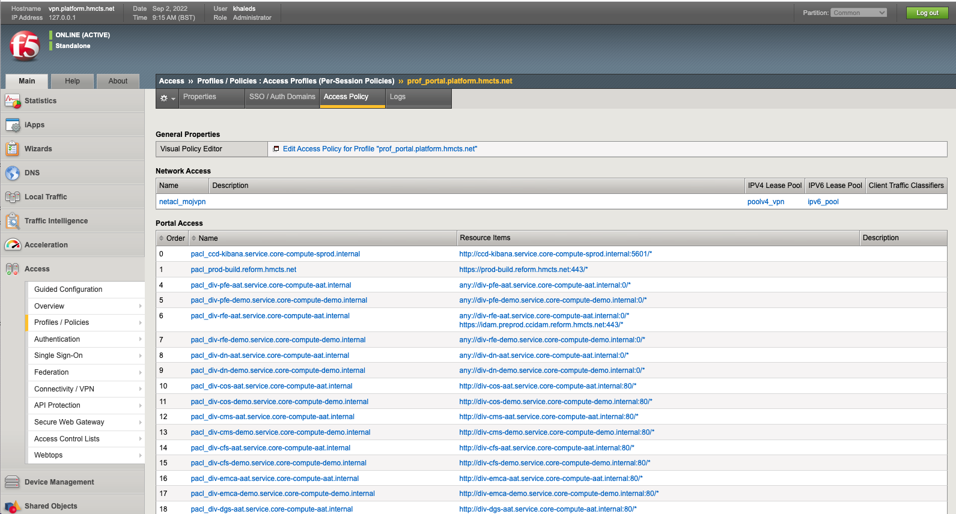

The above screenshot shows what window will be displayed when you log into the GUI.

To access the information in regards to what virus checker the VPN supports you will need to go to the following.

On the left hand side click on Access - Then click on Profiles/Policies and then click on Access Profiles

The below will populate and this is where you will need to choose the correct profile name.

We will be looking at - [prof_portal.platform.hmcts.net](https://vpn.platform.hmcts.net/tmui/Control/jspmap/tmui/accessctrl/profiles/properties.jsp?name=/Common/prof_portal.platform.hmcts.net)

Click on the above

You will then be displayed with the below where you will need to click on the option Access Policy

Once this has loaded you will need to scroll to the top of the page and select the below option.

Need to click on the Edit Access link - This will load a new tab in your web browser

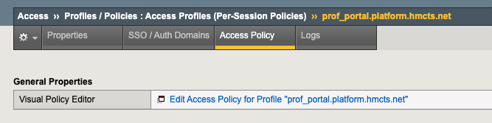

The bottom image shows what will then load up and how you will be able to access the information you require.

From the above image you will see an option to click on Check Local - please click on this option.

You can see in the below image you will now be able to access all the information you require.

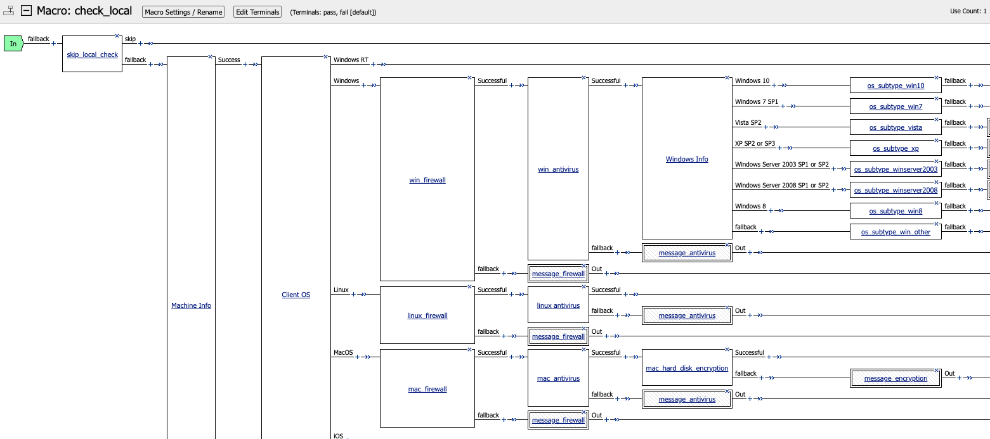

Dependant on what Operating System the user is using you will need to confirm this first before trying to click on the options to see what is being displayed.

I clicked on Windows antivirus as I wanted to check which antivirus was supported with F5 VPN.

